**Name: Navjyot Netaji Sakhalkar**

**PRN No: 2019BTECS00011**

**Practical No 5 B:To design and develop web pages using HTML fundamental and formatting elements**

**Problem Statement 1:**

Design and develop a static web page using HTML for Sports blog. Access it locally and in LAN using web server.

**Github:**

[**Navjyot07/PL-3 (github.com)**](http://navjyot07/PL-3%20(github.com))

**Deployed at:** [**https://pl3-assg-5b-q1.web.app/**](https://pl3-assg-5b-q1.web.app/)

**HTML Code:**

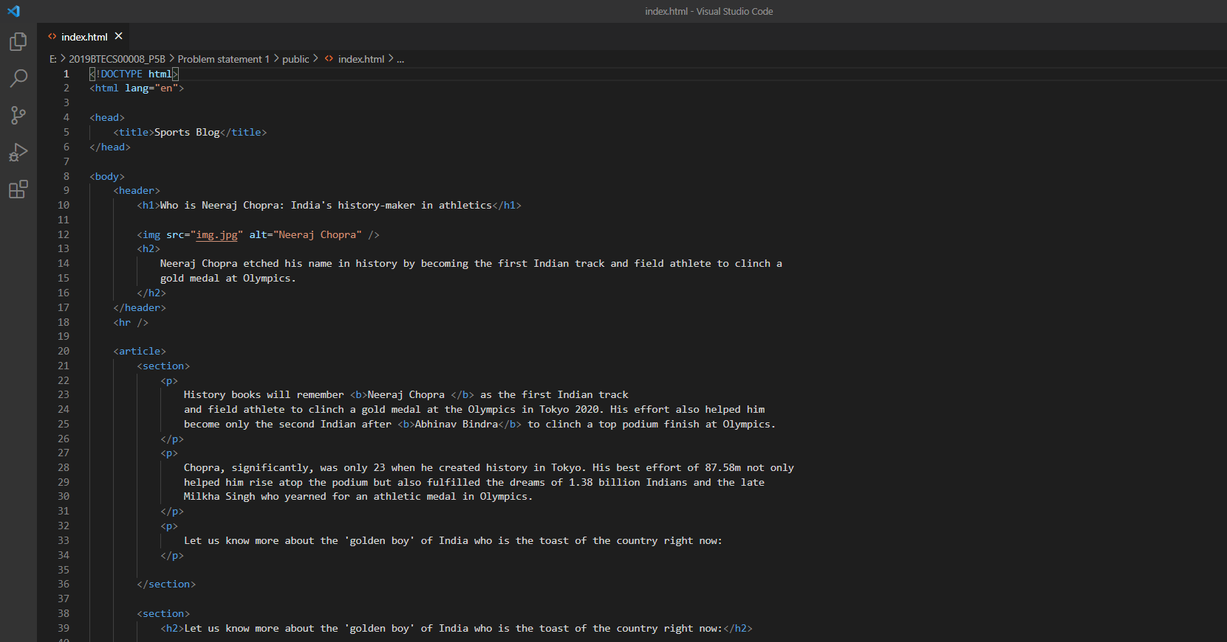

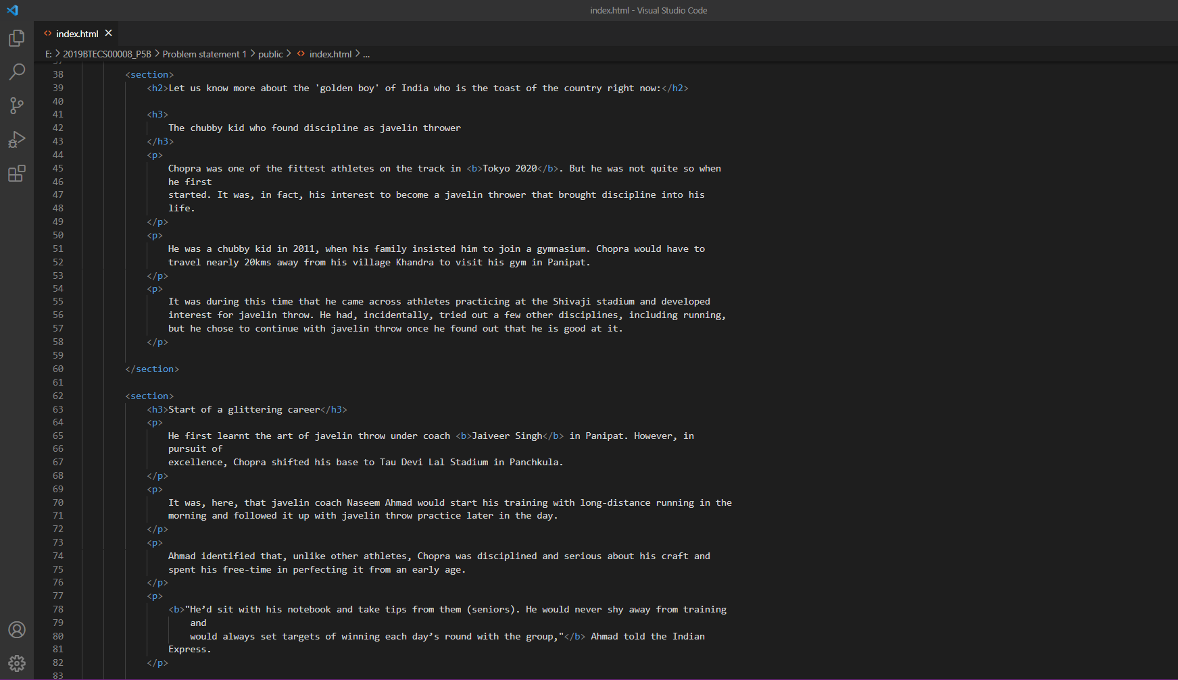

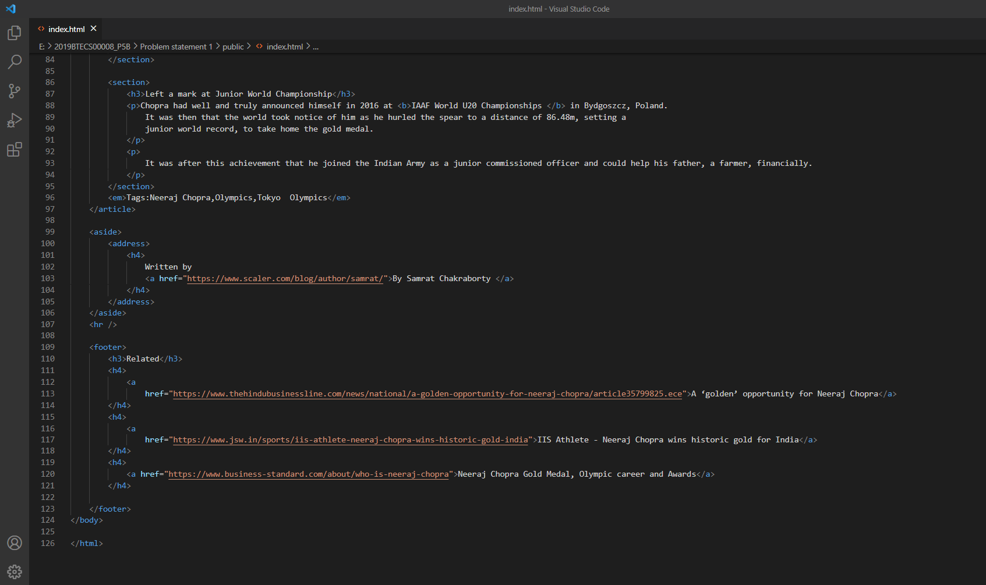

**Website:**

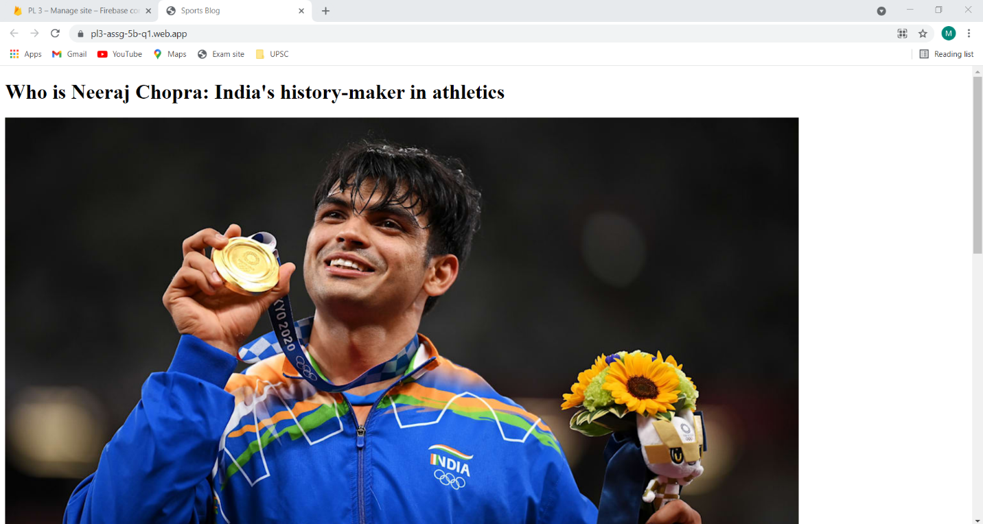

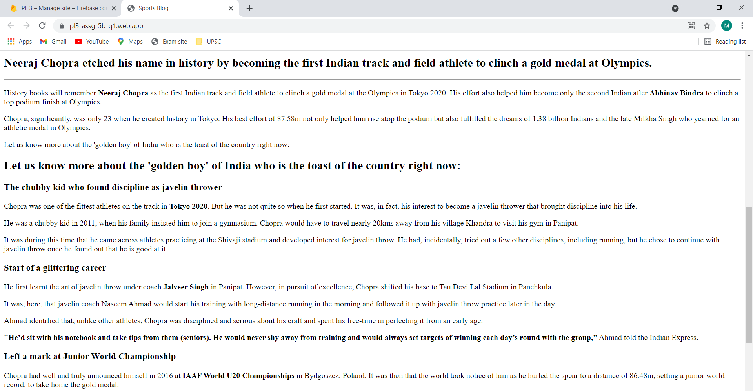

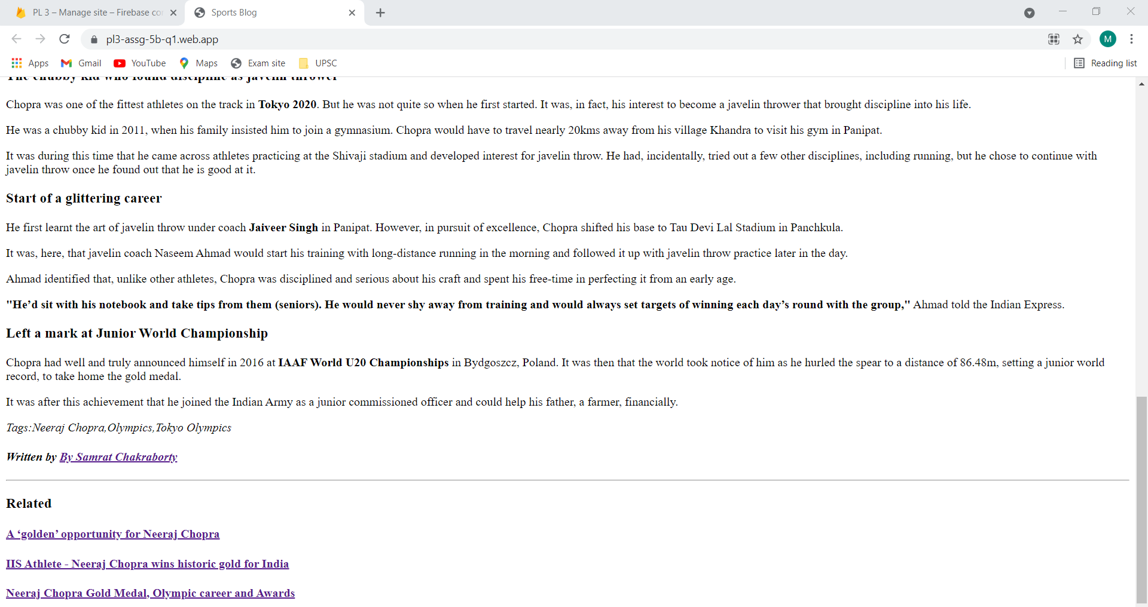

**Problem Statement 2:** Design and develop a static web page using HTML for following requirement. Access it locally and in LAN using web server. It should have following sections:

1. Problem Statement: Write a program in any language to find the sum of the series 1 +11 + 111 + 1111 + ... n terms.

2. Code

3. Sample Input

4. Sample Output

5. Variables used in the program

**Github:**

[**Navjyot07/PL-3 (github.com)**](http://navjyot07/PL-3%20(github.com))

**Deployed at:** [**https://pl3-assg-5b-q2.web.app/**](https://pl3-assg-5b-q2.web.app/)

**HTML Code:**

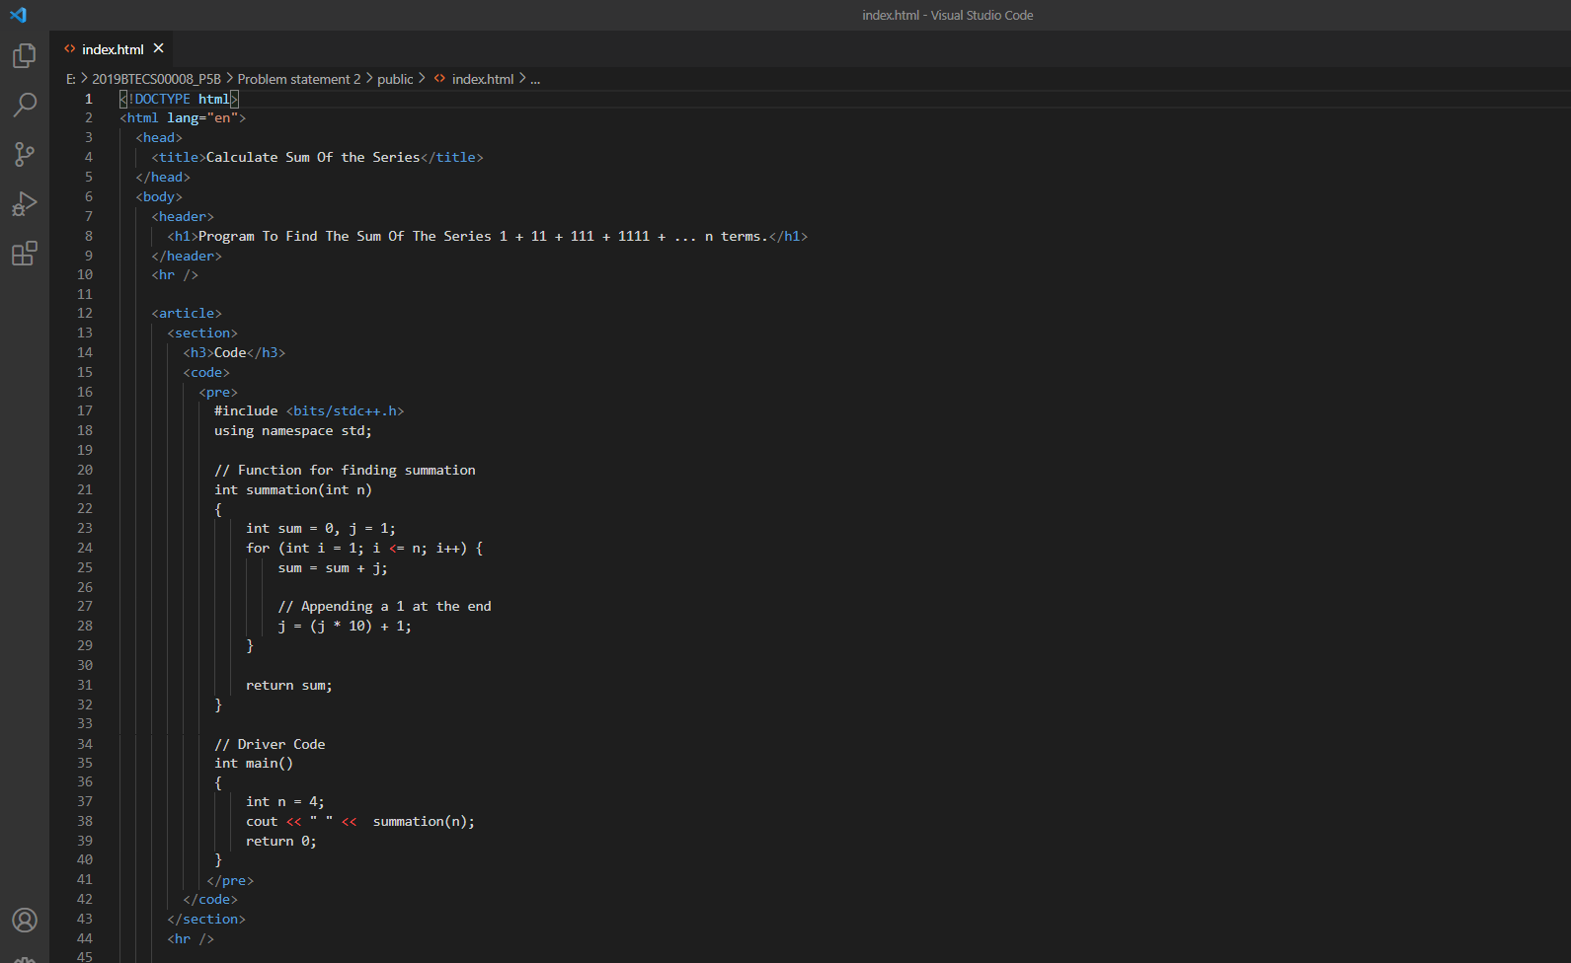

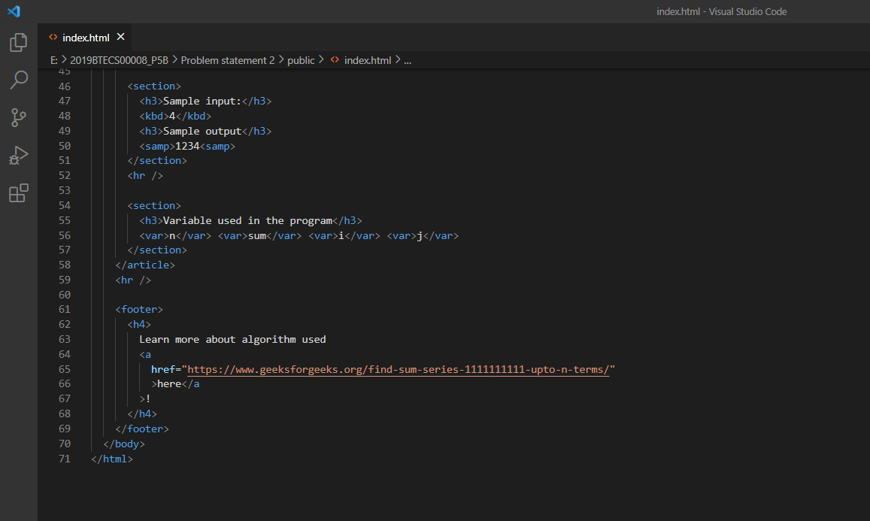

**Website:**

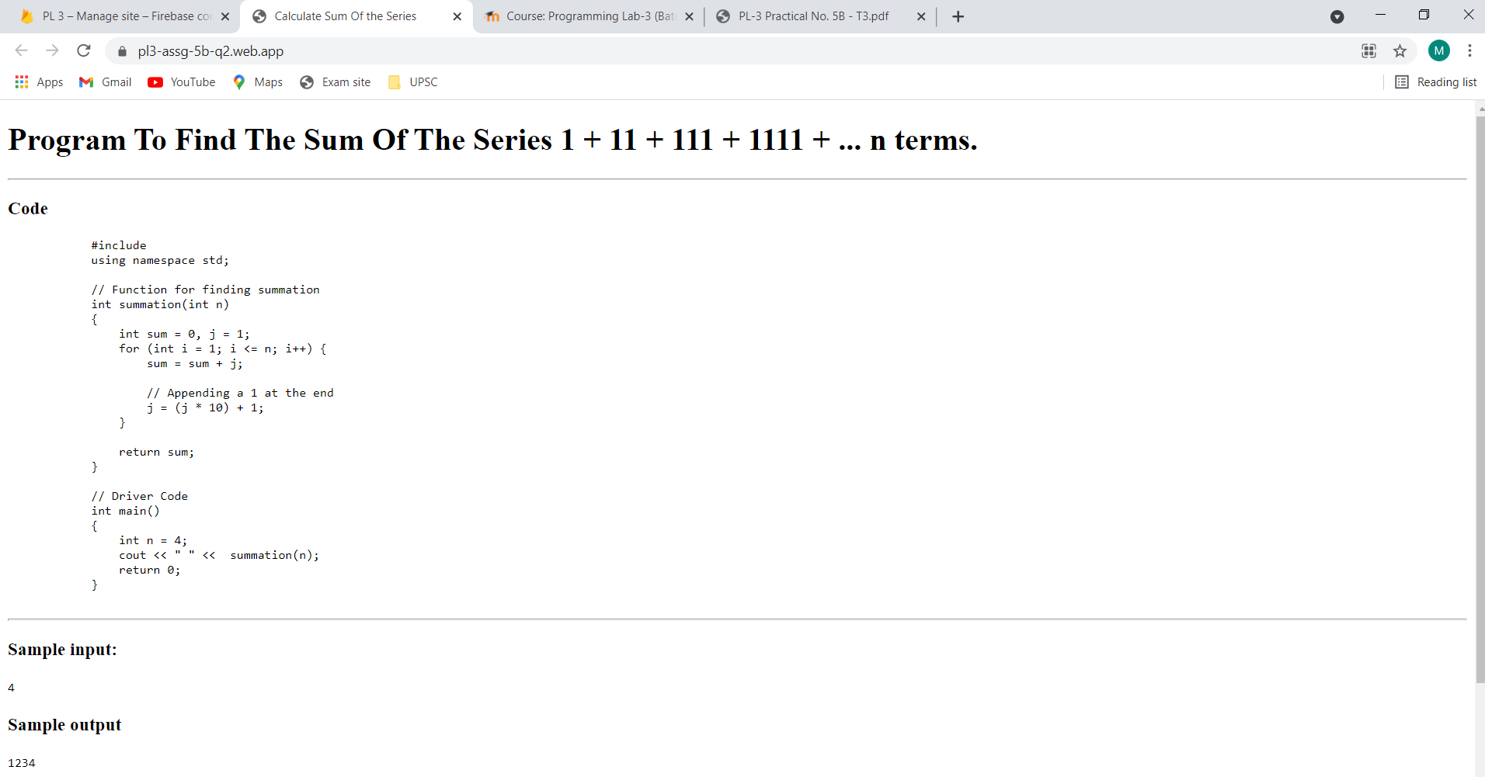

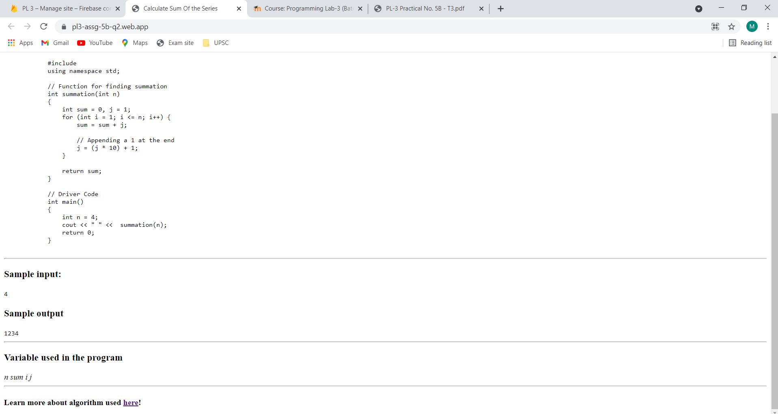

**Problem Statement 3:** Design and develop a static web page using HTML for following requirement. Access it locally and in LAN using web server.

It should have following sections:

1. Any three quotes from https://www.brainyquote.com/ with the name of person

who quoted it.

**Github:**

[**Navjyot07/PL-3 (github.com)**](http://navjyot07/PL-3%20(github.com))

**Deployed at:** [**https://pl3-assg-5b-q3.web.app/**](https://pl3-assg-5b-q3.web.app/)

**HTML Code:**

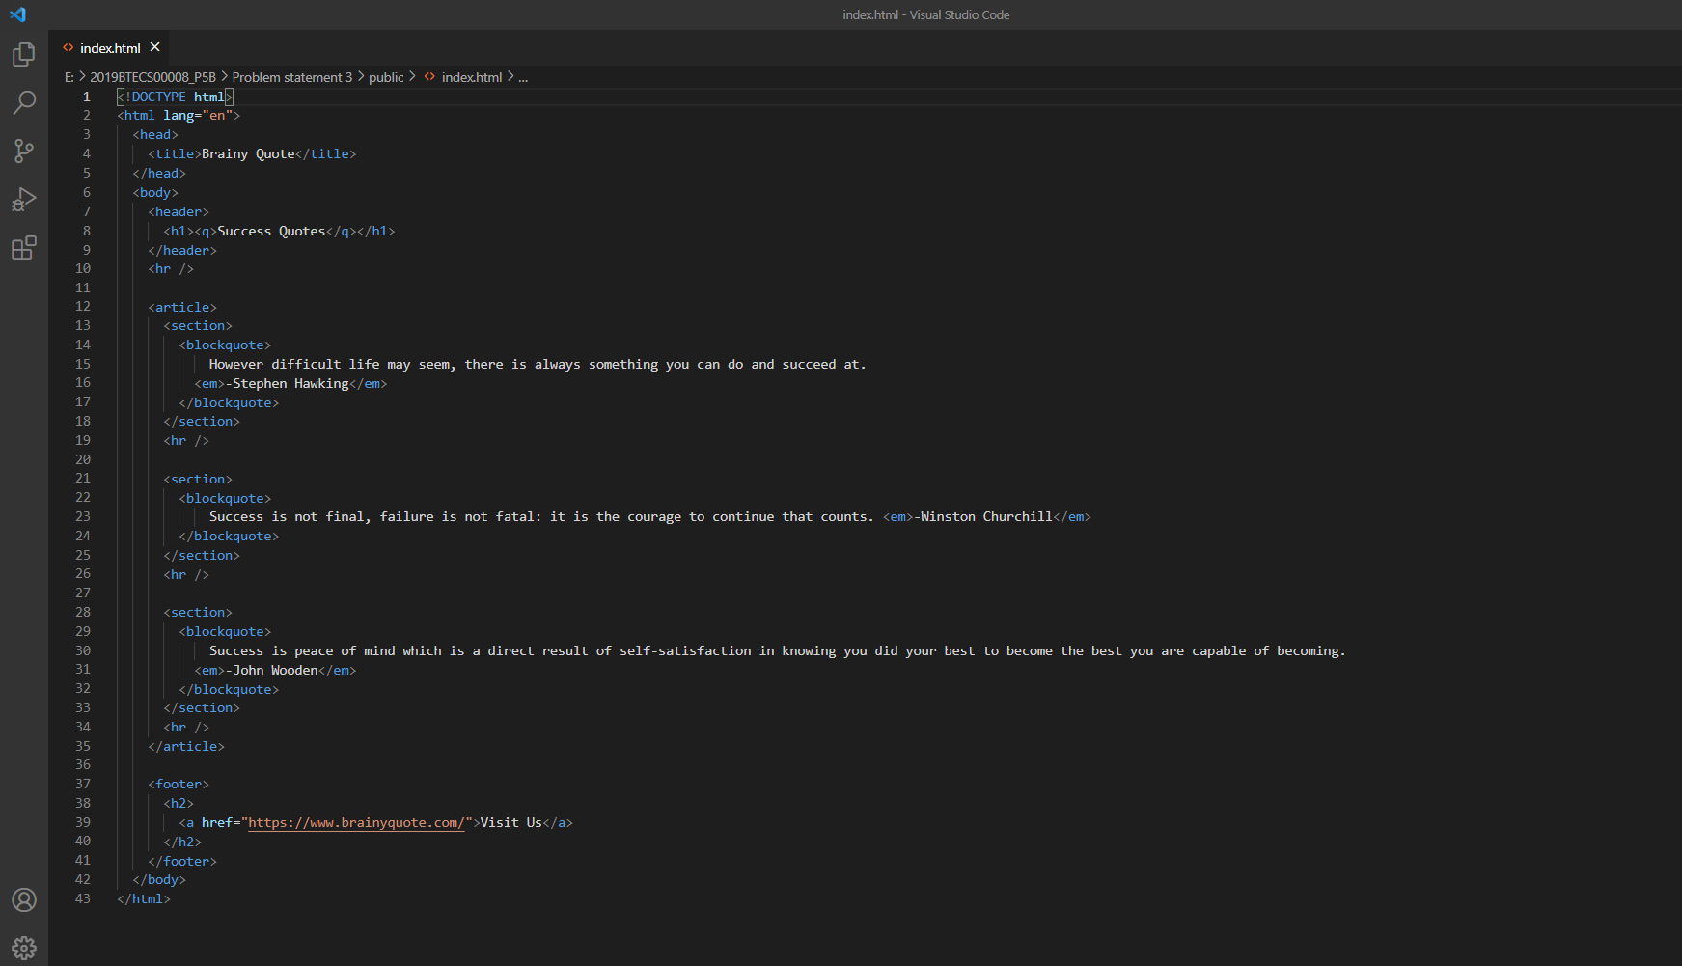

**Website:**

